**TABA 2023/2024 Software Development**

Accessing this document is also possible through the link:

<https://github.com/sergio-oliveira-br/Software-Development>

Sergio Vinicio da Silva Oliveira – x23170981

06/01/2024

1. **a) and 2.a) URLGenerator.java**







**/\***

**\*\* The application prompts the user to provide one single line**

**\*\* of text with the name of the company, for example:**

**\*\* Meta Platforms Inc, Google LLC, Amazon Inc., Deloitte Touche Tohmatsu Ltd.**

**\*\* (Please note that you are not required to validate the input,**

**\*\* we assume that the input is well formed.)**

**\*\* Next, the application uses the given company name to generate/create**

**\*\* the corresponding URL containing a Protocol, Hostname, and Path.**

**\*\* The URL is created using several rules.**

**\*/**

**/\***

**\*\* Protocol -> https:**

**\*\* Hostname -> moodle2023.ncirl.ie**

**\*\* Path -> course/view.php?id=768**

**\*/**

**/\***

**\*\* Examples:**

**\*\***

**\*\* ftp://Google_LLC.org/FAQ**

**\*\* ftp://Deloite_Touche_Tohmatsu_Ltd.edu/FAQ**

**\*\* ftp://Monsters_Inc.edu/bio**

**\*\* coap://Meta_Ltd.edu/bio**

**\*/**

**/\***

**\* @author Sergio Oliveira**

**\* TABA 2023/2024**

**\* e-mail: x23170981**

**\* Student ID: x23170981@student.ncirl.ie**

**\*/**

**public class URLGenerator**

**{**

**//DECLARE VARIABLES**

**private String companyName; //input**

**private String url; //output**

**//Using in Rule (a), (e) and (f)**

**private String newCompanyName;**

**//Using in Rule (c)**

**private StringBuffer strBuff;**

**//Using in Rule (e)**

**private int numConsonants;**

**char vowel;**

**//Using in Rule (f)**

**int numPairsVowel = 0;**

**char currentChar; //using to identify the pairs (i)**

**char nextChar; //close to each other (i + 1)**

**//int length;**

**//CONSTRUCTOR**

**public URLGenerator()**

**{}**

**//COMPUTE METHOD**

**//Rule (a) URL Protocol:**

**//Replace "Meta" to "coap", otherwise "ftp"**

**public void urlProtocol()**

**{**

**if(companyName.toLowerCase().contains("meta"))**

**{**

**url = "coap://" + companyName;**

**}**

**else**

**{**

**url = "ftp://" + companyName;**

**}**

**}**

**//Rule (b) Hostsname:**

**//Replace incorporated, limited or limited liability company to**

**//"Inc", "Ltd" or "LCC"**

**public void urlHostName()**

**{**

**String lowerCaseURL = url.toLowerCase(); //converting everyting to lower case**

**if (lowerCaseURL.contains("incorporated"))**

**{**

**url = url.replaceFirst("(?i)incorporated", "Inc");**

**}**

**else if (lowerCaseURL.contains("limited liability company"))**

**{**

**url = url.replaceFirst("(?i)limited liability company", "LCC");**

**}**

**else if (lowerCaseURL.contains("limited"))**

**{**

**url = url.replaceFirst("(?i)limited", "Ltd");**

**}**

**}**

**//Rule (c) Hostsname:**

**//Replace space to underscore "_"**

**public void newUrlHostname()**

**{**

**strBuff = new StringBuffer();**

**for(int i = 0; i < url.length(); i++)**

**{**

**if (url.charAt(i) == ' ')**

**{**

**strBuff.append('_');**

**}**

**else**

**{**

**strBuff.append(url.charAt(i));**

**}**

**}**

**newCompanyName = strBuff.toString();**

**}**

**//Rule (d) Hostsname:**

**//Don't change the name**

**//Rule (e) Hostsname:**

**//Company's names has a total of consonants:**

**public void Consonants()**

**{**

**for (int i = 0; i < companyName.length(); i++)**

**{**

**char vowel = companyName.charAt(i);**

**if(vowel == 'a' || vowel == 'e' ||**

**vowel == 'i' || vowel == 'o' || vowel == 'u')**

**{**

**//System.out.println(companyName);**

**//System.out.println("check the method and number");**

**}**

**else if(vowel != ' ')**

**{**

**numConsonants++;**

**}**

**}**

**//odd number of consonants, add ".org" at the end**

**if(numConsonants % 2 != 0)**

**{**

**//System.out.println("* Since the number of consonants is odd, " +**

**// "\nit was included: '.org' at the end of your hostname.");**

**newCompanyName += ".org";**

**}**

**//even number of consonants, add ".edu" at the end**

**else**

**{**

**//System.out.println("* Since the number of consonants is even, " +**

**// "\nit was included: '.edu' at the end of your hostname." );**

**newCompanyName += ".edu";**

**}**

**}**

**//Rule (f) Pairs of Vowels:**

**//Count the number of pairs of vowels next to each other:**

**public void PairsOfVowels()**

**{**

**numPairsVowel = 0;**

**for(int i = 0; i < companyName.length() - 1; i++)**

**{**

**currentChar = Character.toLowerCase(newCompanyName.charAt(i));**

**nextChar = Character.toLowerCase(newCompanyName.charAt(i + 1));**

**if ("aeiouAEIOU".indexOf(currentChar) != -1 && "aeiouAEIOU".indexOf(nextChar) != -1)**

**{**

**numPairsVowel++;**

**}**

**}**

**// for 0 add "/bio"**

**if (numPairsVowel == 0)**

**{**

**newCompanyName = newCompanyName + "/bio";**

**//System.out.println("\nThe number of pairs of vowels is: " + numPairsVowel);**

**//System.out.println("For this reason, I added '/bio' at the end.");**

**}**

**// from 1 to 3 add "/FAQ"**

**else if (numPairsVowel <= 3)**

**{**

**newCompanyName = newCompanyName + "/FAQ";**

**//System.out.println("\nThe number of pairs of vowels is: " + numPairsVowel);**

**//System.out.println("In this case, I added '/FAQ' at the end.");**

**}**

**//from 3 up add "/Glossary"**

**else if (numPairsVowel > 3 )**

**{**

**//System.out.println("\nThe number of pairs of vowels is: " + numPairsVowel);**

**//System.out.println("Uau, it's 'Glossary' added at the end.");**

**newCompanyName = newCompanyName + "/Glossary";**

**}**

**}**

**/\***

**\* \*\*\*\*\*\*\*\*\*\*\*\*\*\*\*\*\*\*\*\*\*\*\*\*\*\*\*\*\*\*\*\*\*\*\*\*\*\*\*\*\*\*\*\*\*\*\*\*\*\*\*\*\*\*\*\*\*\*\*\*\*\*\*\*\*\*\*\*\*\*\***

**\***

**\* PART 2 - The method should compute whether the given URLs are valid**

**\***

**\* \*\*\*\*\*\*\*\*\*\*\*\*\*\*\*\*\*\*\*\*\*\*\*\*\*\*\*\*\*\*\*\*\*\*\*\*\*\*\*\*\*\*\*\*\*\*\*\*\*\*\*\*\*\*\*\*\*\*\*\*\*\*\*\*\*\*\*\*\*\*\***

**\***

**\* Penultimate (i.e. second to last) digit of your student ID**

**\* ID: 23170981 - Sergio Oliveira**

**\* Assigned URL - Amazon URLs**

**\***

**\* Functionality: Check the validity of an Amazon URL**

**\* A valid Amazon URL satisfies all the following rules:**

**\* -> it must contain “amazon” or “aws” in the URL hostname.**

**\* -> It cannot be shorter than 5 characters.**

**\* -> It cannot be longer than 16 characters.**

**\* -> It can only contain letters (i.e. a – z inclusive, A – Z inclusive), digits (i.e. 0 – 9 inclusive), and underscores (i.e. ‘_’), forward slashes (i.e. ‘/’), and periods (i.e. ‘.’)**

**\* -> If it contains more than one dot ("."), there can only be exactly two dots**

**\***

**\*/**

**/\***

**\* \*\*\*\*\*\*\*\*\*\*\*\*\*\*\*\*\*\*\*\*\*\*\*\*\*\*\*\*\*\*\*\*\*\*\*\*\*\*\*\*\*\*\*\*\*\*\*\*\*\*\*\*\*\*\*\*\*\*\*\*\*\*\*\*\*\*\*\*\*\*\***

**\***

**\* !IMPORTANT! I don't remember seeing Boolean in the classroom, so I won't use it.**

**\***

**\* \*\*\*\*\*\*\*\*\*\*\*\*\*\*\*\*\*\*\*\*\*\*\*\*\*\*\*\*\*\*\*\*\*\*\*\*\*\*\*\*\*\*\*\*\*\*\*\*\*\*\*\*\*\*\*\*\*\*\*\*\*\*\*\*\*\*\*\*\*\*\***

**\*/**

**public void Validation()**

**{**

**//it must contain “amazon” or “aws” in the URL hostname.**

**System.out.println("-> Your URL contain 'Amazon' or 'aws': ");**

**String lowerCaseNewCompany = newCompanyName.toLowerCase();**

**if(lowerCaseNewCompany.contains("amazon"))**

**{**

**System.out.println(newCompanyName);**

**System.out.println(" True");**

**}**

**else if(lowerCaseNewCompany.contains("aws"))**

**{**

**System.out.println(newCompanyName);**

**System.out.println(" True");**

**}**

**else**

**{**

**System.out.println(lowerCaseNewCompany);**

**System.out.println(" False, does not contain 'Amazon' either 'aws'!");**

**}**

**// ***** ***** ***** ***** ***** ***** \*\*\*\*\***

**//SHOUDL I NEED TO ELIMINATE THE "FTP://" & "COAP://" ?**

**//NO, IT WAS SAID THAT --> "URL containing a Protocol, Hostname, and Path." <--**

**// ***** ***** ***** ***** ***** ***** \*\*\*\*\***

**//It cannot be shorter than 5 characters & It cannot be longer than 16 characters.**

**System.out.println("\n-> Is there a range of 5 to 16 characters?");**

**for(int i = 0; i < newCompanyName.length(); i++)**

**{}**

**//System.out.println(" Has: " + newCompanyName.length() + " characters" );**

**if(newCompanyName.length() > 4 && newCompanyName.length() < 17)**

**{**

**System.out.println(" True");**

**}**

**else**

**{**

**System.out.println(" False, it has: " + newCompanyName.length() + " characters");**

**}**

**// ***** ***** ***** ***** ***** ***** \*\*\*\*\***

**//SHOUDL I NEED TO ELIMINATE THE "FTP://" & "COAP://" ?**

**//NO, IT WAS SAID THAT --> "URL containing a Protocol, Hostname, and Path."**

**// ***** ***** ***** ***** ***** ***** \*\*\*\*\***

**//It can only contain letters (i.e. a – z inclusive, A – Z inclusive),**

**// digits (i.e. 0 – 9 inclusive), and underscores (i.e. ‘_’),**

**// forward slashes (i.e. ‘/’), and periods (i.e. ‘.’)**

**//!IMPORTANT**

**/* To ensure the code worked, I took the liberty of adding ':' */**

**System.out.println("\n-> Can contain: 'a to z', 'A to Z', '0 to 9', '/' and '.'");**

**int pass = 0; //if match with score of newCompanyName pass.**

**for(int i = 0; i < newCompanyName.length(); i++)**

**{**

**currentChar = newCompanyName.charAt(i);**

**if ((currentChar >= 'a' && currentChar <= 'z') ||**

**(currentChar >= 'A' && currentChar <= 'Z') ||**

**(currentChar >= '0' && currentChar <= '9') ||**

**currentChar == '/' || currentChar == '.'||**

**currentChar == ':' || currentChar == '_')**

**/* To ensure the code worked, I took the liberty of adding ':' and '_' */**

**{**

**pass++;**

**//TEST**

**//System.out.println(currentChar);**

**//System.out.println("True");**

**}**

**else**

**{**

**//TEST**

**System.out.println(" This characters is not allowed: " + currentChar);**

**//System.out.println(" False, that's not allowed.");**

**}**

**}**

**if (pass == newCompanyName.length()) //if match, pass.**

**{**

**//TEST**

**//System.out.println("Pass: " + pass + "newCompanyName: " + newCompanyName.length());**

**System.out.println(" True");**

**System.out.println("- - - - - - - - - -\n");**

**}**

**else**

**{**

**//TEST**

**//System.out.println("Pass: " + pass + "newCompanyName: " + newCompanyName.length());**

**System.out.println(" False");**

**System.out.println("- - - - - - - - - -\n");**

**}**

**}**

**//SETTERS**

**public void setCompanyName(String companyName)**

**{**

**this.companyName = companyName;**

**}**

**public void setNewCompanyName(String newCompanyName)**

**{**

**this.newCompanyName = newCompanyName;**

**}**

**public void setUrl(String url)**

**{**

**this.url = url;**

**}**

**public void setVowel(char vowel)**

**{**

**this.vowel = vowel;**

**}**

**public void setNumConsonants(int numConsonants)**

**{**

**this.numConsonants = numConsonants;**

**}**

**public void setNumPairsVowel(int numPairsVowel)**

**{**

**this.numPairsVowel = numPairsVowel;**

**}**

**//GETTERS**

**public String getCompanyName()**

**{**

**return companyName;**

**}**

**public String getNewCompanyName()**

**{**

**return newCompanyName;**

**}**

**public String getUrl()**

**{**

**return url;**

**}**

**public char getVowel()**

**{**

**return vowel;**

**}**

**public int getNumConsonants()**

**{**

**return numConsonants;**

**}**

**public int getNumPairsVowel()**

**{**

**return numPairsVowel;**

**}**

**}**

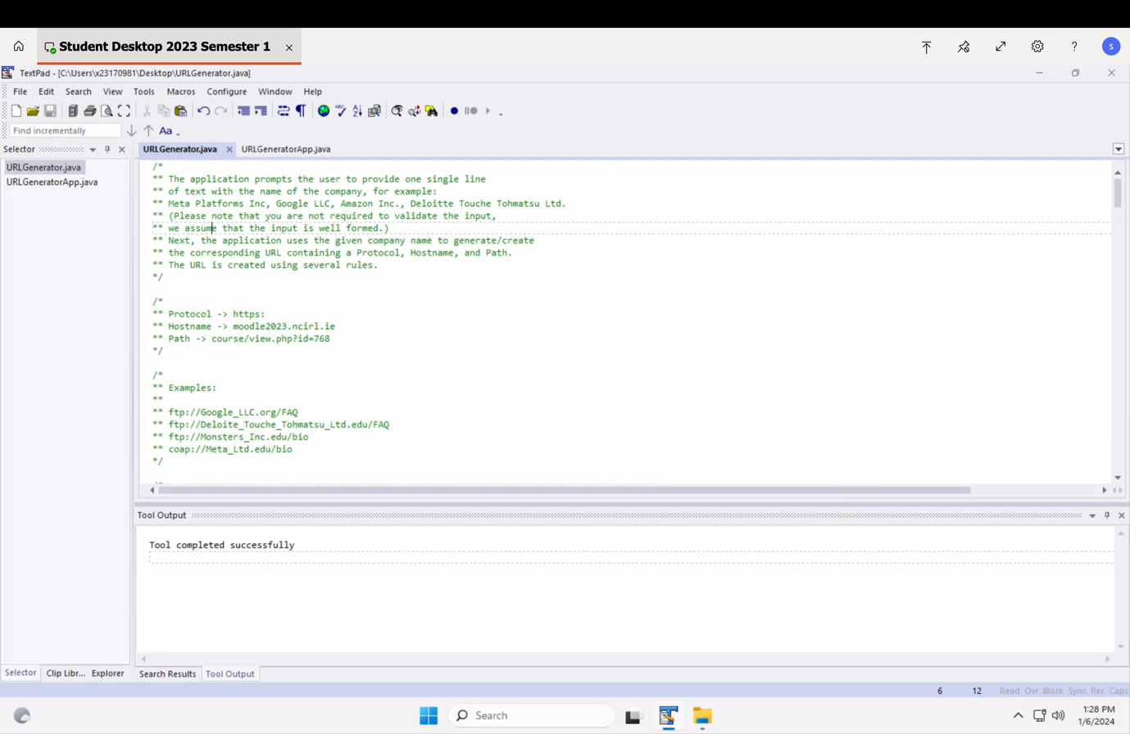

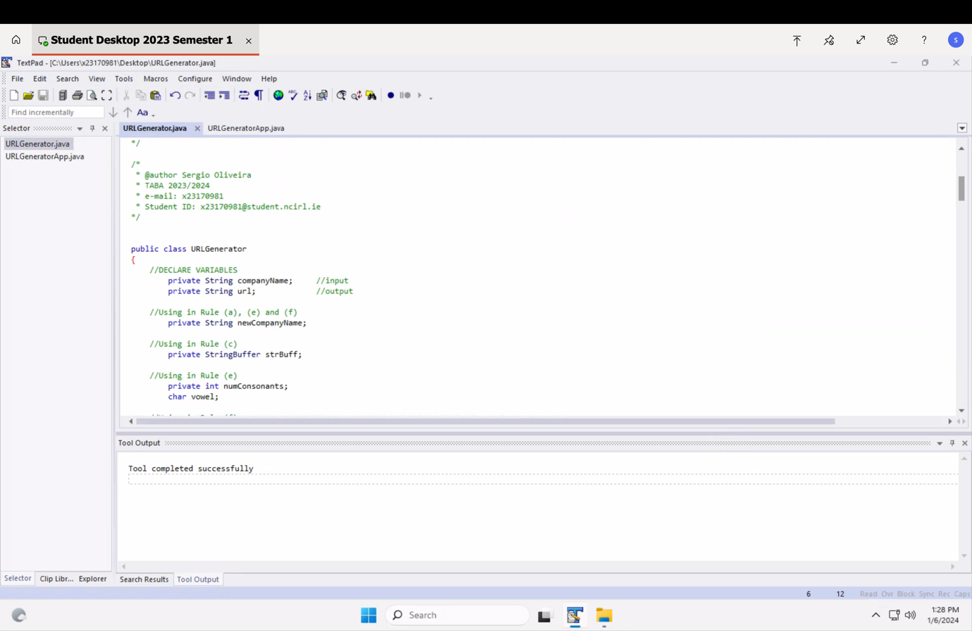

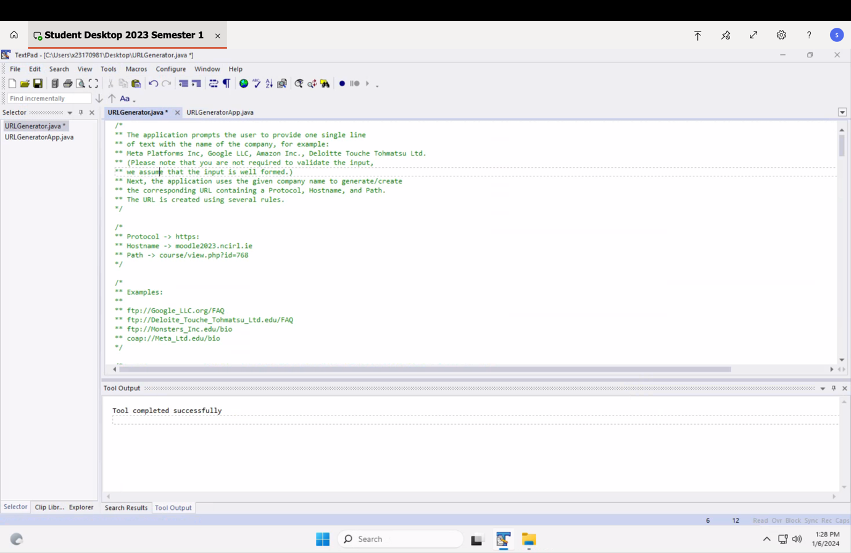

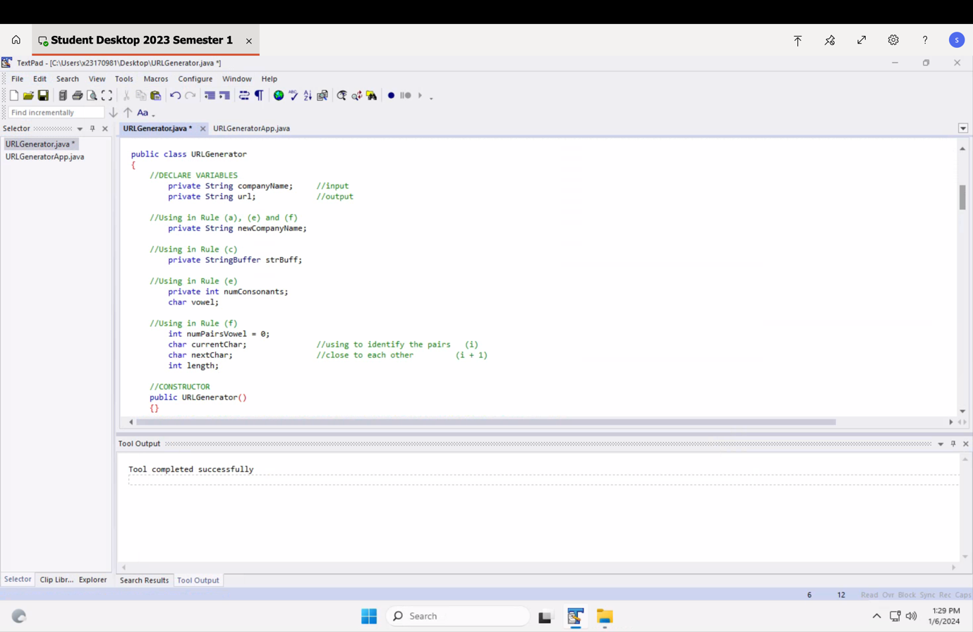

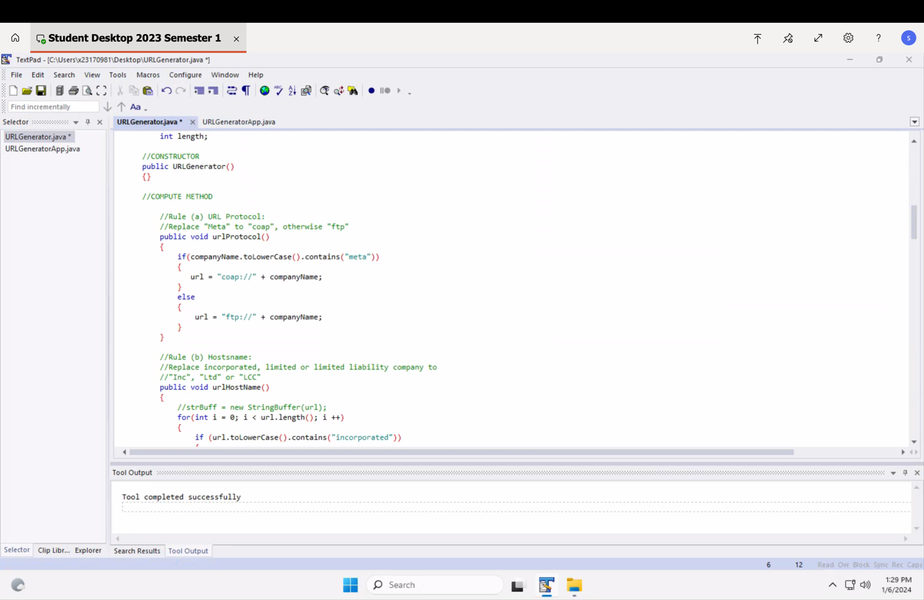

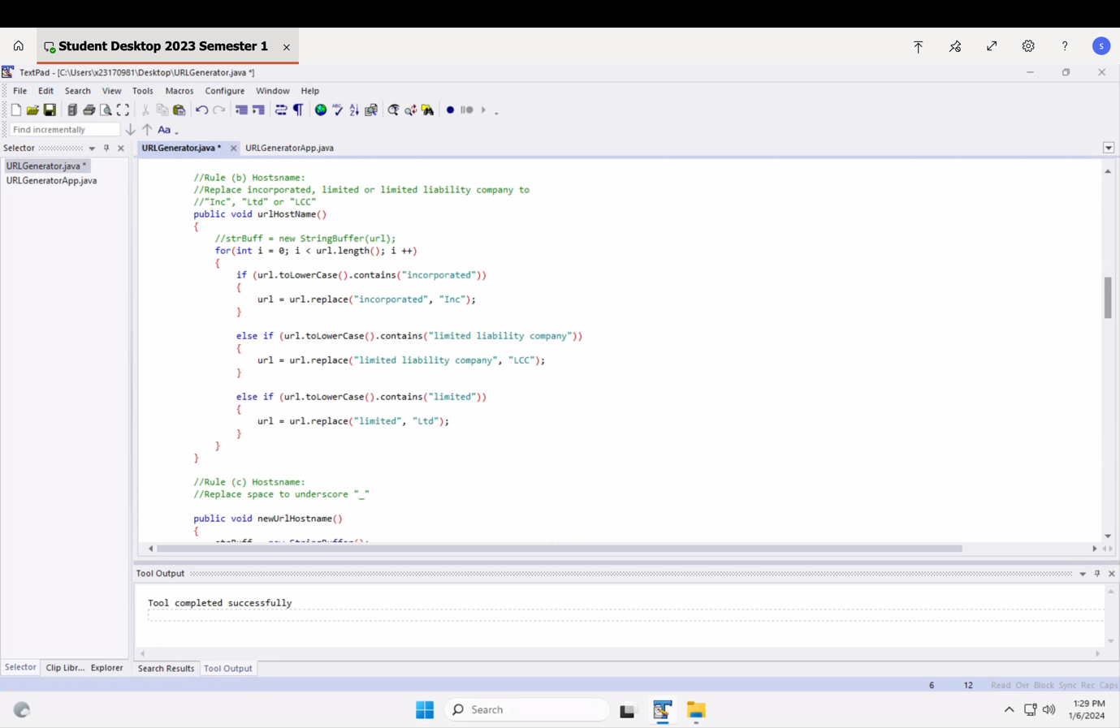

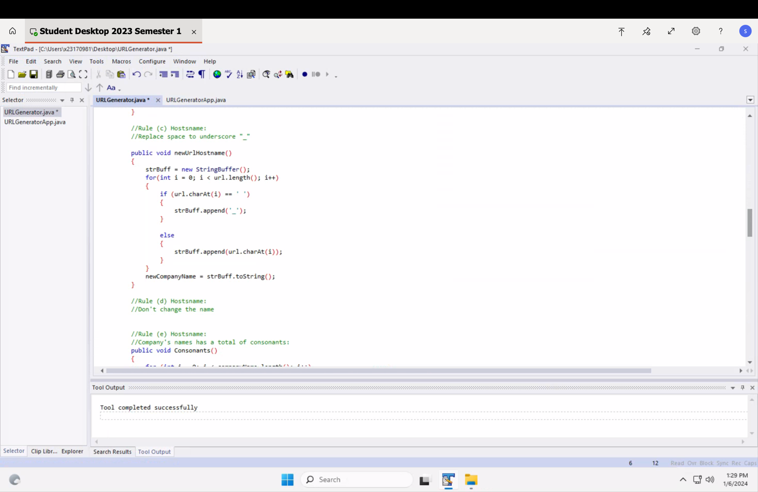

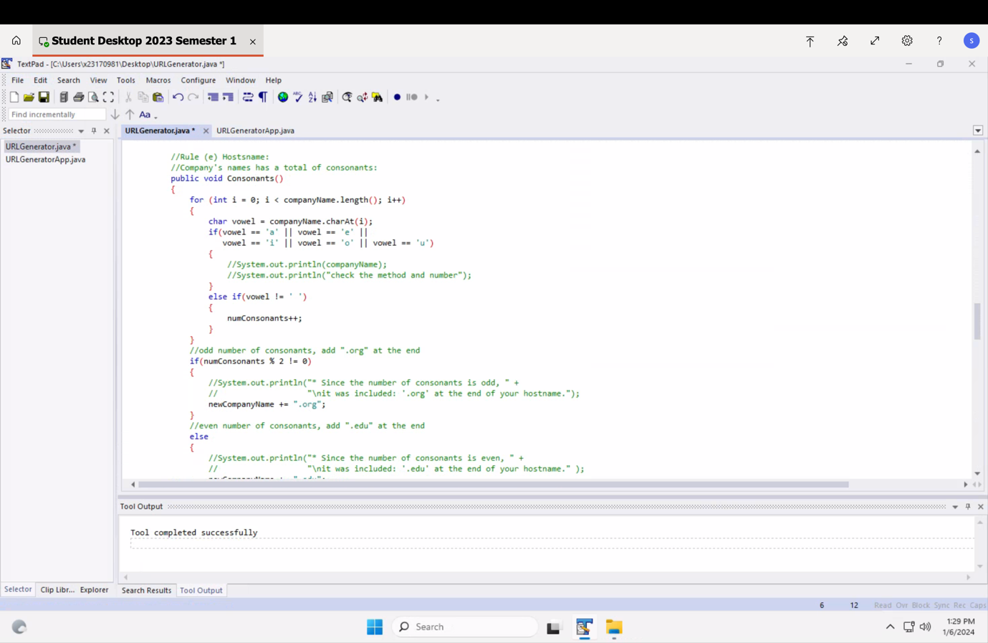

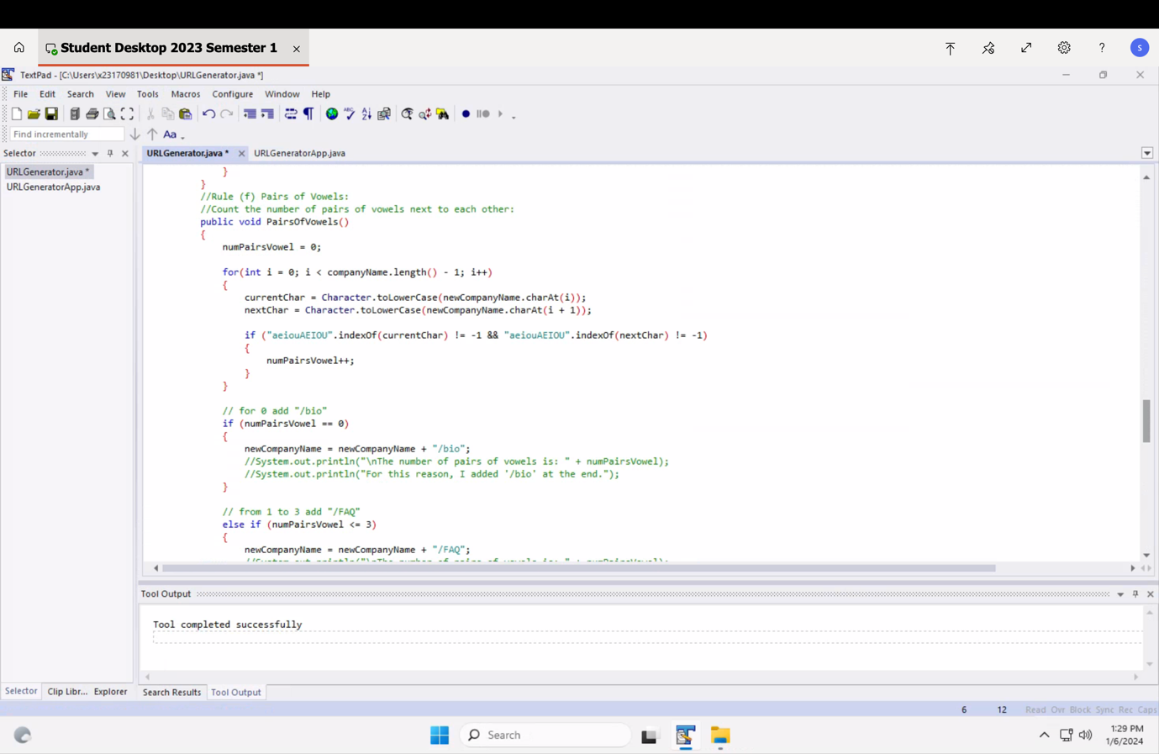

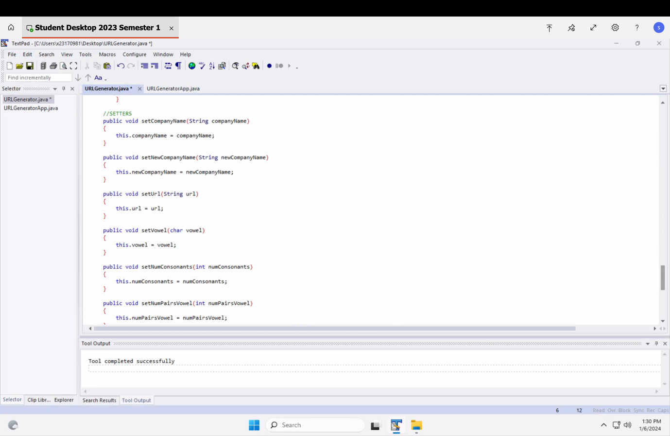

**2.a) URLGenerator**





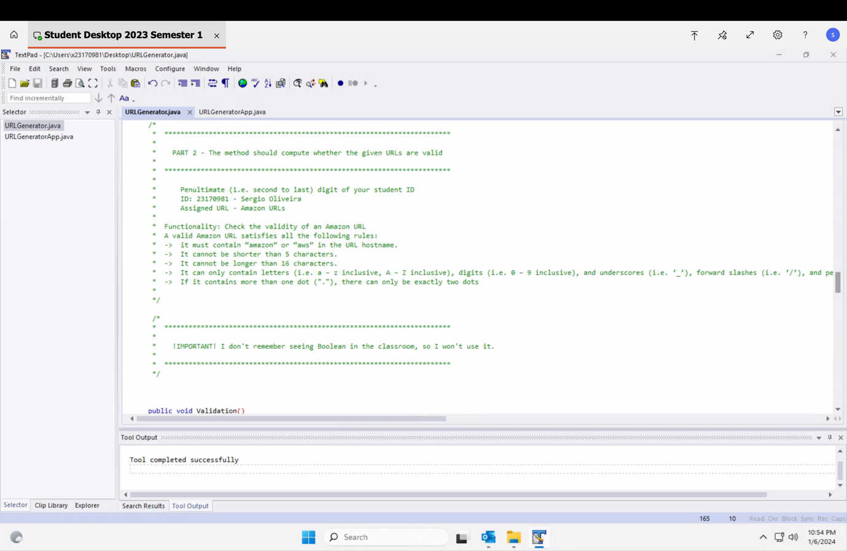

**1.b) and 2.b) URLGeneratorApp**

**/\***

**\*\* The application prompts the user to provide one single line**

**\*\* of text with the name of the company, for example:**

**\*\* Meta Platforms Inc, Google LLC, Amazon Inc., Deloitte Touche Tohmatsu Ltd.**

**\*\* (Please note that you are not required to validate the input,**

**\*\* we assume that the input is well formed.)**

**\*\* Next, the application uses the given company name to generate/create**

**\*\* the corresponding URL containing a Protocol, Hostname, and Path.**

**\*\* The URL is created using several rules.**

**\*/**

**/\***

**\*\* Protocol -> https:**

**\*\* Hostname -> moodle2023.ncirl.ie**

**\*\* Path -> course/view.php?id=768**

**\*/**

**/\***

**\*\* Examples:**

**\*\***

**\*\* ftp://Google_LLC.org/FAQ**

**\*\* ftp://Deloite_Touche_Tohmatsu_Ltd.edu/FAQ**

**\*\* ftp://Monsters_Inc.edu/bio**

**\*\* coap://Meta_Ltd.edu/bio**

**\*/**

**/\*\***

**\* @author Sergio Oliveira**

**\* TABA 2023/2024**

**\* e-mail: x23170981**

**\* Student ID: x23170981@student.ncirl.ie**

**\*/**

**import java.util.Scanner;**

**public class URLGeneratorApp**

**{**

**public static void main(String[] args)**

**{**

**//DECLARE VARIABLES**

**String companyName; //input**

**String url; //output**

**int urlQty; //Part (b), my last digite is 1. Approach ID: MCNA1**

**String newCompanyName[];**

**//declare and create the object**

**URLGenerator myU = new URLGenerator();**

**Scanner sc = new Scanner(System.in);**

**//INPUT**

**//Welcome Msg**

**System.out.println("\nThis is TABA 2023 by Sergio Oliveira" +**

**"\nWelcome to the Url Generator!");**

**//Approach ID: MCNA1 -> Ask the user how many URLs they would like to generate**

**do**

**{**

**System.out.println("How many URLs would you like to generate?");**

**urlQty = sc.nextInt(); //User inputs a number, program stores it**

**sc.nextLine();**

**if(urlQty < 0)**

**{**

**System.out.println("Opps! Invalid Input.");**

**System.out.println("Please enter a positive number.\n");**

**}**

**else if (urlQty > 3) //I need to change to a another number**

**{**

**System.out.println("Are you sure about this number?");**

**System.out.print("Type 'y' or 'Y' for Yes or anything else for No."); //I ne**

**char c = sc.next().charAt(0);**

**if(c == 'y' || c== 'Y')**

**{**

**sc.nextLine();**

**break;**

**}**

**}**

**}**

**while(urlQty < 0 );**

**//My Array**

**newCompanyName = new String[urlQty];**

**//User enters the Company Name**

**for(int i = 0; i < urlQty; i++)**

**{**

**System.out.println("\nPlease enter your Company Name #" + (i + 1) + ":");**

**newCompanyName[i] = sc.nextLine();**

**}**

**System.out.println("\nHere is a summary and the URLs that were generated:\n");**

**//OUTPUT**

**for(int i = 0; i < urlQty; i++)**

**{**

**myU.setCompanyName(newCompanyName[i]);**

**myU.urlProtocol();**

**myU.urlHostName();**

**myU.newUrlHostname();**

**myU.Consonants();**

**myU.PairsOfVowels();**

**//Introduction**

**System.out.println("\n--------");**

**System.out.println("#" + (i + 1));**

**System.out.println("The Company Name: " + myU.getCompanyName());**

**System.out.println("URL-> " + myU.getNewCompanyName() + "\n");**

**//Rule (all) here is the final answer**

**//System.out.println(myU.getNewCompanyName() + "\n");**

**//Introduction to explanation**

**System.out.print("This URL was created using these rules:\n");**

**//Explaing the rule (e)**

**//myU.Consonants();**

**if (myU.getNumConsonants() % 2 != 0)**

**{**

**System.out.println("* Since the number of consonants is odd, " +**

**"\nit was included: '.org' at the end of your hostname.");**

**}**

**else**

**{**

**System.out.println("* Since the number of consonants is even, " +**

**"\nit was included: '.edu' at the end of your hostname." );**

**}**

**//Explaing the rule (f)**

**myU.PairsOfVowels();**

**System.out.println("\n* The number of pair of vowel is: " + myU.getNumPairsVowel());**

**if (myU.getNumPairsVowel() == 0)**

**{**

**System.out.println(" For this reason, I added '/bio' at the end.");**

**}**

**else if (myU.getNumPairsVowel() <= 3)**

**{**

**System.out.println(" In this case, I added '/FAQ' at the end.");**

**}**

**else if (myU.getNumPairsVowel() > 3)**

**{**

**System.out.println(" Wow, 'Glossary' was added at the end.");**

**}**

**}**

**/\***

**\* \*\*\*\*\*\*\*\*\*\*\*\*\*\*\*\*\*\*\*\*\*\*\*\*\*\*\*\*\*\*\*\*\*\*\*\*\*\*\*\*\*\*\*\*\*\*\*\*\*\*\*\*\*\*\*\*\*\*\*\*\*\*\*\*\*\*\*\*\*\*\***

**\***

**\* PART 2 - The method should compute whether the given URLs are valid**

**\***

**\* \*\*\*\*\*\*\*\*\*\*\*\*\*\*\*\*\*\*\*\*\*\*\*\*\*\*\*\*\*\*\*\*\*\*\*\*\*\*\*\*\*\*\*\*\*\*\*\*\*\*\*\*\*\*\*\*\*\*\*\*\*\*\*\*\*\*\*\*\*\*\***

**\***

**\* Penultimate (i.e. second to last) digit of your student ID**

**\* ID: 23170981 - Sergio Oliveira**

**\* Assigned URL - Amazon URLs**

**\***

**\* Functionality: Check the validity of an Amazon URL**

**\* A valid Amazon URL satisfies all the following rules:**

**\* -> it must contain “amazon” or “aws” in the URL hostname.**

**\* -> It cannot be shorter than 5 characters.**

**\* -> It cannot be longer than 16 characters.**

**\* -> It can only contain letters (i.e. a – z inclusive, A – Z inclusive), digits (i.e. 0 – 9 inclusive), and underscores (i.e. ‘_’), forward slashes (i.e. ‘/’), and periods (i.e. ‘.’)**

**\* -> If it contains more than one dot ("."), there can only be exactly two dots**

**\***

**\*/**

**//Declare Variables**

**char answer;**

**//INPUT**

**System.out.println("\n##############");**

**System.out.println("\nWould you like to validat you URL? ");**

**System.out.println("Press 'y' or 'Y' for Yes, or anything for No.");**

**answer = sc.next().charAt(0);**

**if(answer == 'y' || answer == 'Y')**

**{**

**sc.nextLine();**

**System.out.println("\nLet's start! ");**

**for(int i = 0; i < urlQty; i++)**

**{**

**myU.setCompanyName(newCompanyName[i]);**

**myU.urlProtocol();**

**myU.urlHostName();**

**myU.newUrlHostname();**

**myU.Consonants();**

**myU.PairsOfVowels();**

**System.out.println("#" + (i + 1));**

**myU.Validation();**

**}**

**}**

**else**

**{**

**System.out.println("Okay, bye bye!" +**

**"\nThis was TABA Software Development" +**

**"\n By Sergio Oliveira");**

**}**

**System.out.println("\nTks" +**

**"\nThis was TABA Software Development" +**

**"\nBy Sergio Oliveira");**

**}**

**}**

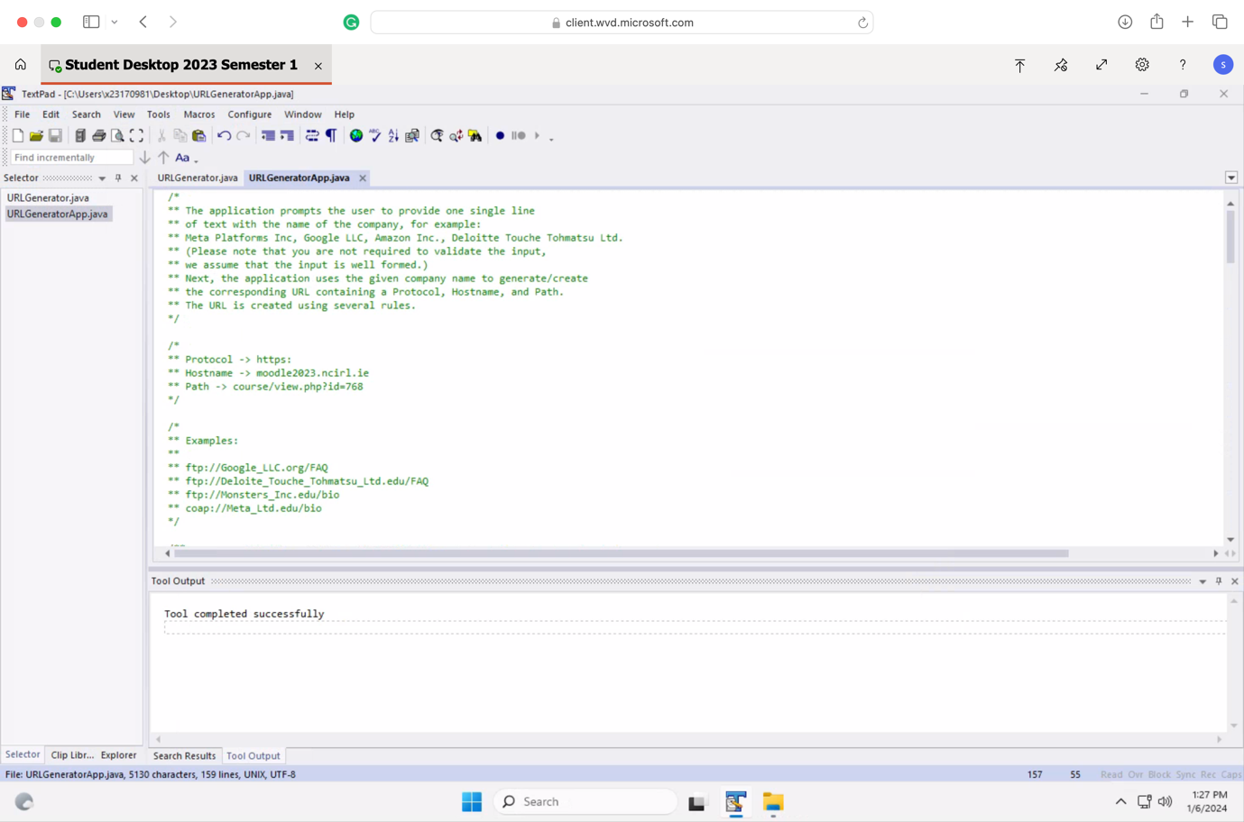

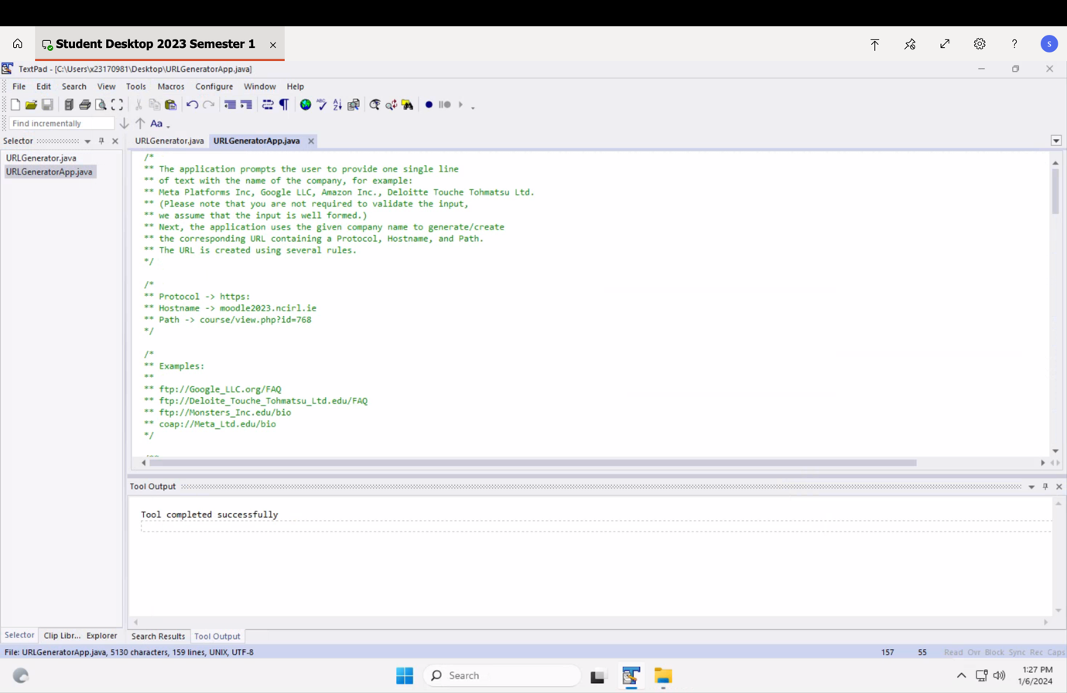

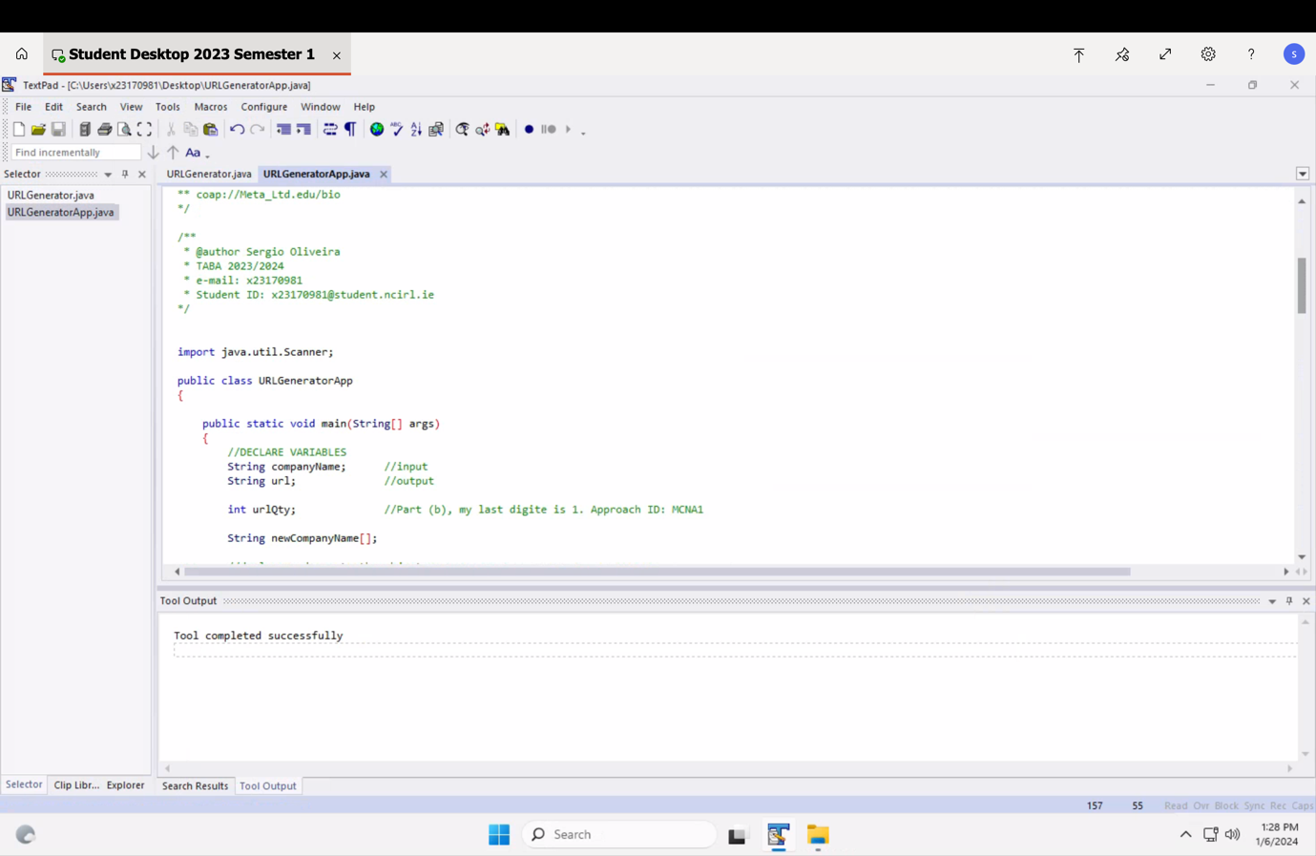

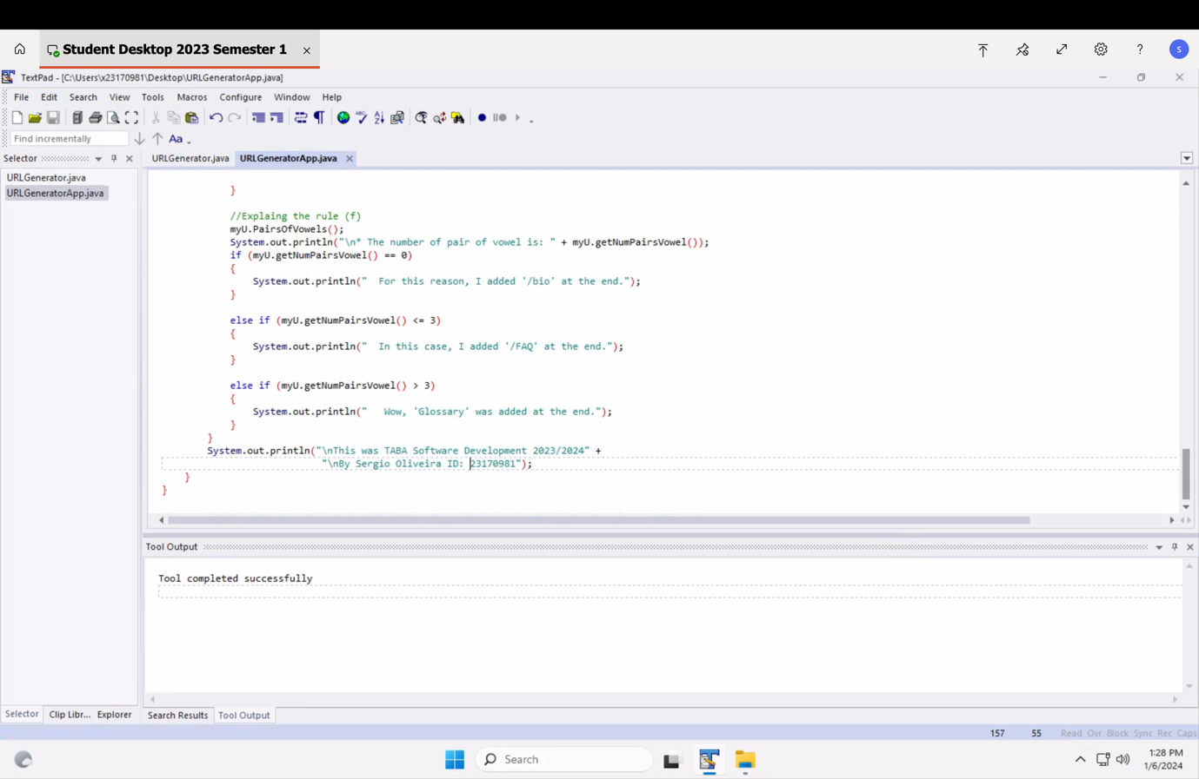

**2.b) URLGeneratorApp**

